FAMOUS ENGLISH AUTHORS

1. WILLIAM SHAKESPEARE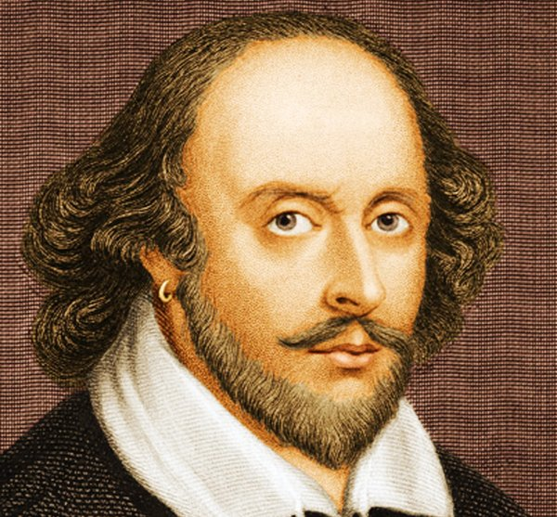
William Shakespeare was an English playwright, poet and actor. He is regarded as the greatest writer in English language and the world’s greatest dramatist. He is often called England’s national poet and the “Bard of Avon”. He was born in England. His extant works, including collaborations, consist of some 39 plays, 154 sonnets, three long narrative poems, and a few other verses, some of uncertain authorship. His plays have been translated into every major living language and are performed more often than those of any other playwright. He remains arguably the most influential writer in English language, and his works continue to be studied and reinterpreted. Shakespeare produced most of his known works between 1589 and 1613. His early plays were primarily comedies and histories and are regarded as some of the best works produced in these genres. He then wrote mainly tragedies until 1608, among them Hamlet, Romeo and Juliet, Othello, King Lear and Macbeth, all considered to be among the finest works in the English language. In the last phase of his life, he wrote tragicomedies and collaborated with other playwrights. He died on 23 April 1616 at the age of 52.
2. CHARLES DICKENS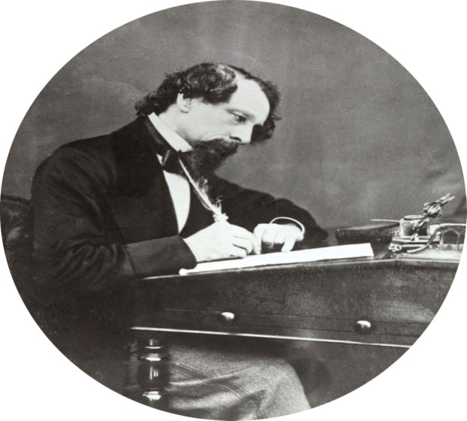
Charles John Huffam Dickens was an English writer and social critic. He created some of the world’s best-known fictional characters and is regarded as the greatest novelist of the Victorian era. He was born on 7 February in Portsmouth, England. His works enjoyed unprecedented popularity during his lifetime and, by the 20^{th-} century, critics and scholars had recognised him as a literary genius. His novels and short stories are widely read. Dickens edited a weekly journal for 20 years, wrote 15 novels, 5 novellas, hundreds of short stories and non-fiction articles, lectured and performed readings extensively, was an indefatigable letter writer and campaigned vigorously for children’s rights, for education, and for other social reforms. Dickens’s literary success began with the 1836 serial publication of The Pickwick Papers. Within a few years Dickens had become an international literary celebrity, famous for his humour, satire and keen observation of character and society. His 1843 novella A Christmas Carol remains especially popular and continues to inspire adaptations in every artistic genre. His 1859 novel A Tale of Two Cities is his best-known work of historical fiction. The most celebrity of his era, he undertook, in response to public demand, a series of public reading tours in the later part of his career.
3. JANE AUSTEN
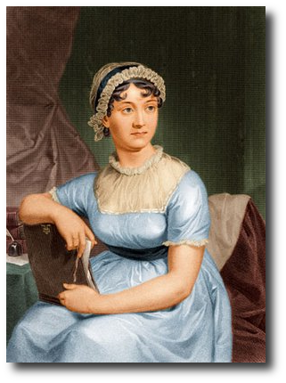
Jane Austen was an English novelist known primarily for her six major novels, which interpret, critique, and comment upon the British landed gentry at the end of the 18th century. She was born on 16 December 1775 in England. Austen’s plots often explore the dependence of women on marriage in the pursuit of favourable social standing and economic security. Her works critique the novels of sensibility of the second half of the 18th century and are part of transition to 19th century literary realism. Her use of biting irony, along with her realism and social commentary, has earned her acclaim among critics and scholars. With the publication of Sense and Sensibility, Pride and Prejudice, Mansfield Park and Emma, she achieved modest success but only little fame in her lifetime since the books were published anonymously. She wrote two other novels-Northanger Abbey and Persuasion, both published posthumously in 1818 and began another, eventually titled Sanditon, but died before its completion. She also left behind three volumes of juvenile writings in manuscript, the short epistolary novel Lady Susan, and the unfinished novel The Watsons. Austen gained far more status after her death, and her six full-length novels have rarely been out of print. She died on 18 July 1817 at the age of 41.
4. GEORGE ORWELL
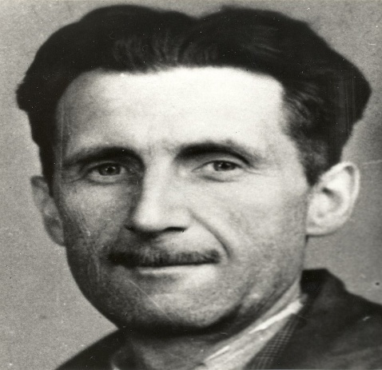
Eric Arthur Blair, better known by his pen name George Orwell, was an English novelist, essayist, journalist and critic. He was born on 25 June 1903. His work is characterised by lucid prose, social criticism, opposition to totalitarianism, and support of democratic socialism. Orwell produced literary criticism and poetry, fiction and polemical journalism. He is known for the allegorical novella Animal Farm and the dystopian novel Nineteen Eighty-Four. His known non-fiction works, including The Road to Wigan Pier, documenting his experience of working-class life in the industrial north of England, and Homage to Catalonia, an account of his experience soldiering for the Republican faction of the Spanish Civil War are as critically respected as his essays on politics and literature, language and culture. Blair was born in India, and raised and educated in England. After school he became an Imperial policeman in Burma, before returning to Suffolk, England, where he began his writing career as George Orwell-a name inspired by a favourite location, the River Orwell. Orwell’s another famous work is the autobiographical Down and Out in Paris and London, which contains essays that recount actual events in a fictionalized form. He died on 21 January 1950 in London.

