English Fest Report
- English club was decided to conduct English Fest
- English Fest was inaugurated by Headmaster Balakumar sir on 06/ 11/ 25.
- Discussed about the importance of English Language
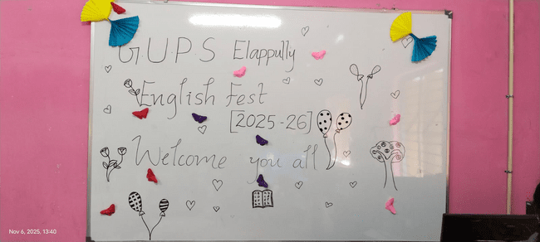

- There was an exhibition of posters, charts, magazine, pictures etc incorporating language elements
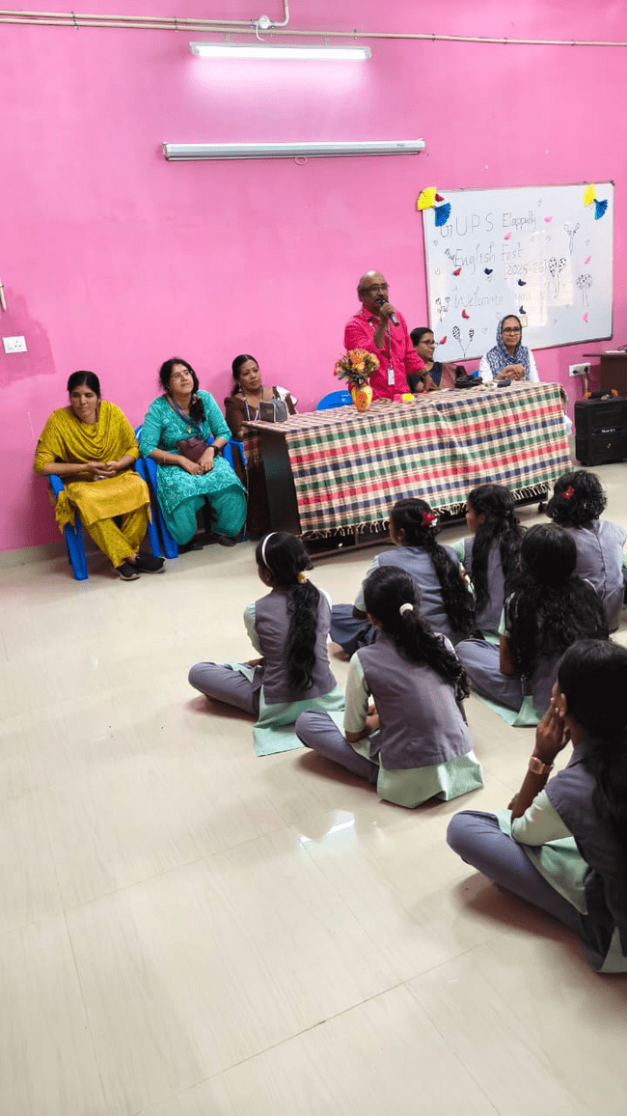

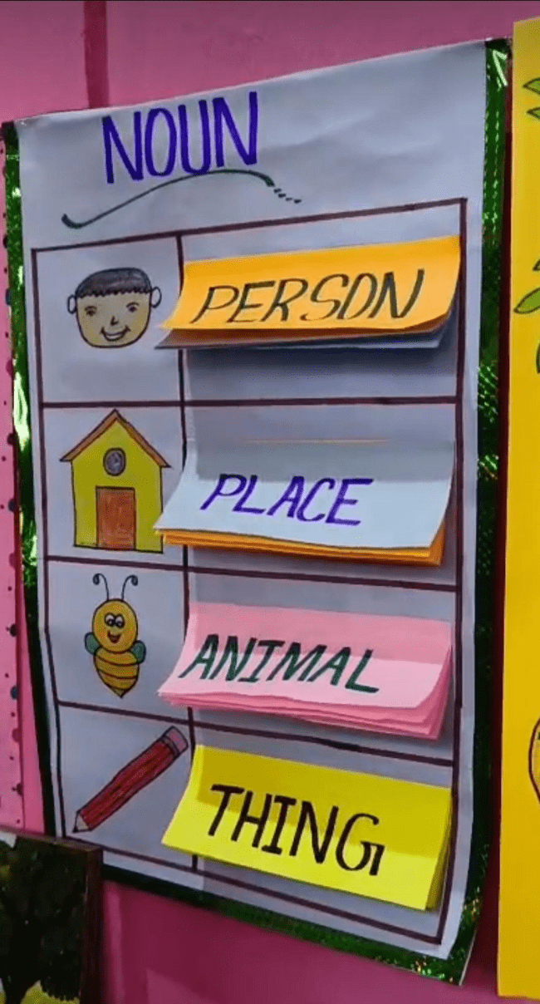

- Cultural programmes such as Recitation, Skit, Elocution, Action song, Choreography, Reels of grammatical elements were held on that day.

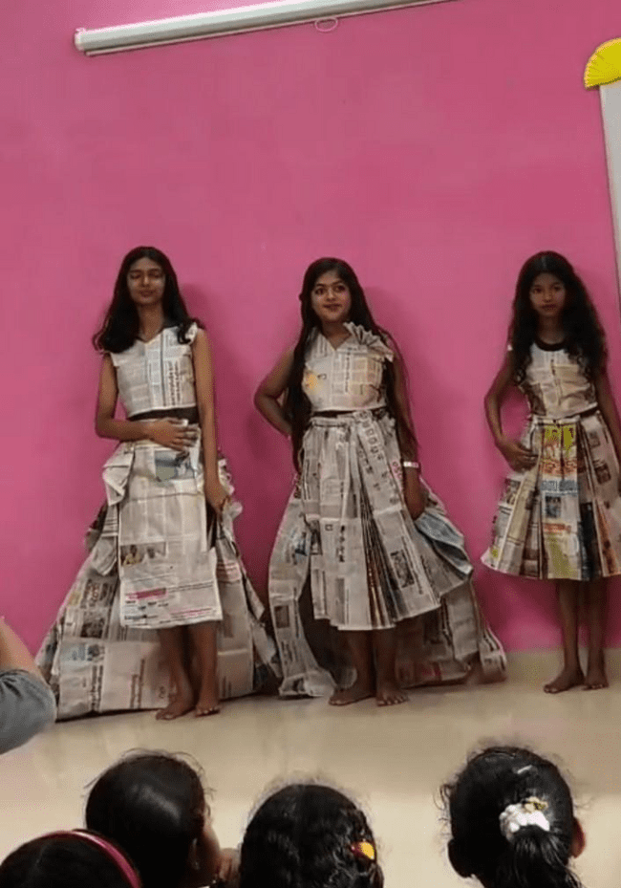
- Through this English Fest, children's interest in the English language increased. They were able to gain proficiency in the English language

. Let us watch video

